NOT NULL Constraint

🌟 Definition
# Source: AI Source: Provided by: [Data Path: Persons Table -> ID Column: 1, Name_En Column: Motasem Essam] -> From: [ChatGPT] on [6/10/2026]
A NOT NULL Constraint is a rule that ensures a column must always contain a value.
It prevents NULL (empty or missing) values from being stored in that column.

🎯 Purpose
# Source: AI Source: Provided by: [Data Path: Persons Table -> ID Column: 1, Name_En Column: Motasem Essam] -> From: [ChatGPT] on [6/10/2026]
The NOT NULL constraint is used to:
- Ensure required information is provided
- Prevent missing data
- Improve data quality
- Enforce business rules

🧠 Simple Example
# Source: AI Source: Provided by: [Data Path: Persons Table -> ID Column: 1, Name_En Column: Motasem Essam] -> From: [ChatGPT] on [6/10/2026]
Customers Table
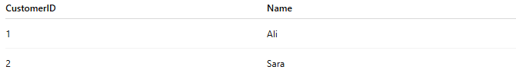
CustomerID | Name
1 | Ali
2 | Sara
If the Name column is NOT NULL:
✅ Valid
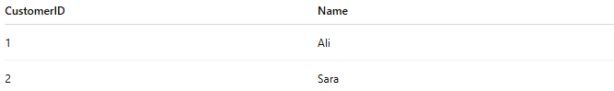
CustomerID | Name
1 | Ali
2 | Sara

❌ Invalid
CustomerID | Name
3 | NULL
The database will reject this record.

🔢 What is NULL?
# Source: AI Source: Provided by: [Data Path: Persons Table -> ID Column: 1, Name_En Column: Motasem Essam] -> From: [ChatGPT] on [6/10/2026]
NULL means:

Unknown
Missing
Not Provided
No Value
NULL is not:
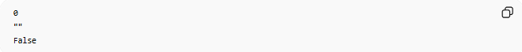
0
""
False
It represents the absence of a value.

📚 Real-World Examples
# Source: AI Source: Provided by: [Data Path: Persons Table -> ID Column: 1, Name_En Column: Motasem Essam] -> From: [ChatGPT] on [6/10/2026]
Customer Registration
Required:

Name
Email
Password
These fields should not be empty.

Student System
Required:
StudentID
StudentName

Product Catalog
Required:
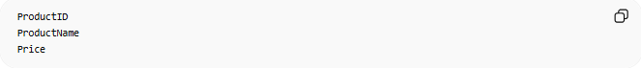
ProductID
ProductName
Price

🗄️ SQL Example
# Source: AI Source: Provided by: [Data Path: Persons Table -> ID Column: 1, Name_En Column: Motasem Essam] -> From: [ChatGPT] on [6/10/2026]
Create Table
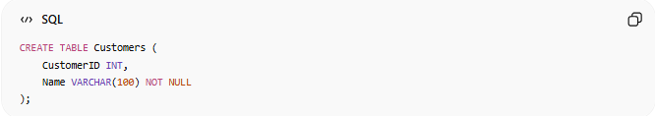
CREATE TABLE Customers (
CustomerID INT,
Name VARCHAR(100) NOT NULL
);

Valid Insert
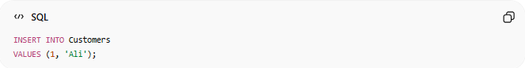
INSERT INTO Customers
VALUES (1, 'Ali');
Result:
Success

Invalid Insert
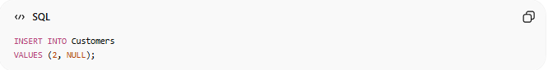
INSERT INTO Customers
VALUES (2, NULL);
Result:
Error
Because Name is NOT NULL.

📊 Database Example
# Source: AI Source: Provided by: [Data Path: Persons Table -> ID Column: 1, Name_En Column: Motasem Essam] -> From: [ChatGPT] on [6/10/2026]
Table Structure
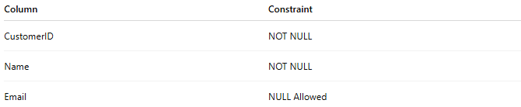
Column | Constraint
CustomerID | NOT NULL
Name | NOT NULL
Email | NULL Allowed

Valid Data
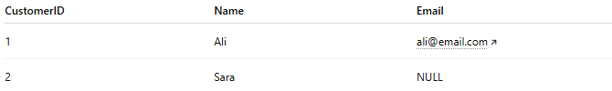
CustomerID | Name | Email
1 | Ali | ali@email.com
2 | Sara | NULL
Email is allowed to be NULL.

Invalid Data
CustomerID | Name
3 | NULL
Name is NOT NULL.

🔢 Characteristics of NOT NULL
# Source: AI Source: Provided by: [Data Path: Persons Table -> ID Column: 1, Name_En Column: Motasem Essam] -> From: [ChatGPT] on [6/10/2026]
A NOT NULL column:
- Must contain a value
- Cannot be empty
- Improves data integrity
- Can be combined with other constraints

🔗 NOT NULL with Primary Key
# Source: AI Source: Provided by: [Data Path: Persons Table -> ID Column: 1, Name_En Column: Motasem Essam] -> From: [ChatGPT] on [6/10/2026]
Every Primary Key automatically has:
UNIQUE
NOT NULL
Example:

CREATE TABLE Students (
StudentID INT PRIMARY KEY,
Name VARCHAR(100)
);
StudentID cannot be NULL.

🌍 Employee Example
# Source: AI Source: Provided by: [Data Path: Persons Table -> ID Column: 1, Name_En Column: Motasem Essam] -> From: [ChatGPT] on [6/10/2026]
Table
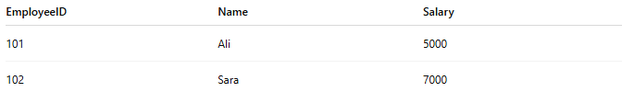
EmployeeID | Name | Salary
101 | Ali | 5000
102 | Sara | 7000
If Name is NOT NULL:
Every employee must have a name.

⚠️ NOT NULL vs NULL Allowed
# Source: AI Source: Provided by: [Data Path: Persons Table -> ID Column: 1, Name_En Column: Motasem Essam] -> From: [ChatGPT] on [6/10/2026]
NOT NULL
Name = Required
Valid:

Ali
Sara
Ahmed
Invalid:
NULL

NULL Allowed
MiddleName = Optional
Valid:

Mohamed
NULL
Ahmed

📊 Comparison
# Source: AI Source: Provided by: [Data Path: Persons Table -> ID Column: 1, Name_En Column: Motasem Essam] -> From: [ChatGPT] on [6/10/2026]
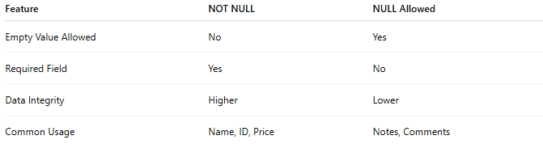
Feature | NOT NULL | NULL Allowed
Empty Value Allowed | No | Yes
Required Field | Yes | No
Data Integrity | Higher | Lower
Common Usage | Name, ID, Price | Notes, Comments

🗄️ Multiple NOT NULL Columns
# Source: AI Source: Provided by: [Data Path: Persons Table -> ID Column: 1, Name_En Column: Motasem Essam] -> From: [ChatGPT] on [6/10/2026]
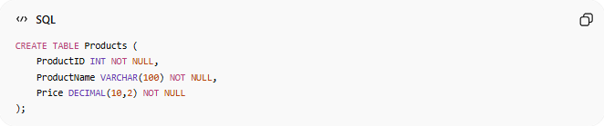
CREATE TABLE Products (
ProductID INT NOT NULL,
ProductName VARCHAR(100) NOT NULL,
Price DECIMAL(10,2) NOT NULL
);
All three columns must contain values.

📚 Common NOT NULL Fields
# Source: AI Source: Provided by: [Data Path: Persons Table -> ID Column: 1, Name_En Column: Motasem Essam] -> From: [ChatGPT] on [6/10/2026]
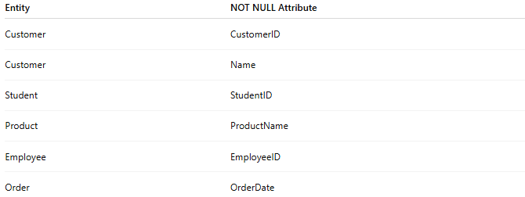
Entity | NOT NULL Attribute
Customer | CustomerID
Customer | Name
Student | StudentID
Product | ProductName
Employee | EmployeeID
Order | OrderDate

🧠 Simple Analogy
# Source: AI Source: Provided by: [Data Path: Persons Table -> ID Column: 1, Name_En Column: Motasem Essam] -> From: [ChatGPT] on [6/10/2026]
Think of a school registration form.
Required fields:

Student Name
Student ID
Date of Birth
You cannot submit the form without filling them in.
These required fields are similar to columns with a NOT NULL Constraint.

🧭 Summary
# Source: AI Source: Provided by: [Data Path: Persons Table -> ID Column: 1, Name_En Column: Motasem Essam] -> From: [ChatGPT] on [6/10/2026]
A NOT NULL Constraint is a rule that prevents a column from storing NULL values. It ensures that required information is always provided, helping maintain data quality and integrity. Common NOT NULL columns include Name, ID, Price, and Order Date.

